**STL efficiency**

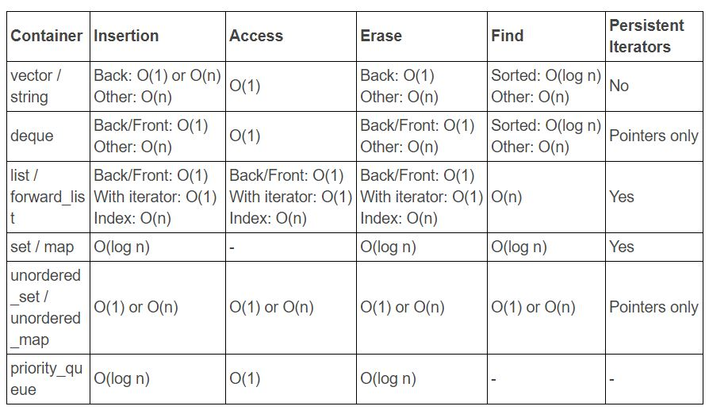

**map**

map is always sorted, and it is implemented by binary tree(key, value).

It does not have duplicated key.

keys can not be modified, they are read-only. values can be modified

itr should be assigned before the manipulation.

* When to use:

Usually, main purpose of using map stl container is for efficient search operations and sorted order retrieval.

* Declaration:

map<char,int> mymap;

* Insertion:

mymap.insert(pair<char,int>('a',100));

mymap.insert(make_pair('z',200));

mymap.insert(itr,make_pair('b',400));

//reveal if insertion is sucessful, and it will fail because of duplicated key.

pair<map<char,int>::iterator,bool> ret;

ret=mymap.insert(make_pair('a',1000));

* Show content:

for(itr=mymap.begin();itr!=mymap.end();itr++){

cout << itr->first <<" => " << itr->second <<endl;

} // same as cout << (*itr).first <<" => " << (*itr).second <<endl;

* Find:

itr=mymap.find('z');

* Erase:

itr=mymap.find('c');

if(itr!=mymap.end()){

mymap.erase(itr);

}//Be Careful: if iterator does not find content, this will return the end iterator

int iferase = mymap.erase('b');

**Unordered map**

Unordered map’s order is messy, and it’s implemented by hash table(key, value).

It does not have duplicated key.

keys can not be modified, they are read-only. values can be modified

uitr should be assigned before the manipulation.

* When to use:

For efficient search operations, use std::map when you need elements to automatically be sorted. Use std::unordered_map other times.

* Declaration:

unordered_map<char,int> u_map;

* Insertion:

u_map.insert(pair<char,int>('a',100));

u_map.insert(make_pair('z',200));

u_map.insert(uitr,make_pair('b',400));

//reveal if insertion is sucessful, and it will fail because of duplicated key.

pair<unordered_map<char,int>::iterator,bool> ret2;

ret2=u_map.insert(make_pair('a',1000));

* Show content:

for(uitr=u_map.begin();uitr!=u_map.end();uitr++){

cout << uitr->first <<" => " << uitr->second <<endl; // same as cout << (*uitr).first <<" => " << (*uitr).second <<endl;

}

* Find:

uitr=u_map.find('a');

* Erase:

uitr=u_map.find('c');

if(uitr!=u_map.end()){//Be Careful: if iterator does not find content, this will return the end iterator

u_map.erase(uitr);

}

int ifuerase = u_map.erase('b');

* Hash table APIs:

//load factor(no. of elements/ no. of buckets)

cout << u_map.load_factor()<<endl;

//bucket count

cout << u_map.bucket_count()<<endl;

//bucket position of a

cout << u_map.bucket('a')<<endl;

**Binary file**

* Write a number: n

fstream file;

file.open("binaryfile.bin", ios::out|ios::binary);

file.write((char*)&n,sizeof(n));

file.close();

* Read a number: r

fstream finC;

finC.open("binaryfile.bin",ios::in|ios::binary);

finC.read((char*)&r,sizeof(r));

finC.close();

**Split string**

vector<string> split(string str, char delimiter) {

vector<string> outcome;

stringstream ss(str); // Turn the string into a stream.

string substr; //split part

while(getline(ss, substr, delimiter)) {

outcome.push_back(substr);

}

return outcome;

}

**Regression**

Use the function in CMatrix.h

Regress y on 1, x1,x2,x3,…

Y=[y] , X=[1 x1 x2 x3 …]

Beta_hat=((X'X)^-1)X'Y

**Shared_ptr**

Manage memory resource to prevent memory leak(forget to delete) or dangling pointer(forget deleting, undefined behavior).

An object should be assigned to a smart pointer as soon as it is created. Raw pointer should not be used

//Bad example

Dog* d =new Dog("Tank");//bad idea

shared_ptr<Dog> p(d); //p.use_count()==1

cout << p.use_count() <<endl;

shared_ptr<Dog> p2(d); //p2.use_count()==1

cout << p.use_count() <<endl;

* Declaration:

#include<memory>

shared_ptr<Dog> p(new Dog("Gun"));

shared_ptr<Dog> p(d);

shared_ptr<Dog> p=make_shared<Dog>("Tank");//faster and saver

* Count number:

p.use_count()

* Delete memory:

shared_ptr<Dog> p1=make_shared<Dog>("Gun");

shared_ptr<Dog> p2=make_shared<Dog>("Tank");

//Gun is deleted after any of the following three opeerations

p1=p2;

p1=nullptr;

p1.reset();

* Customized deleter:

shared_ptr<Dog> p2=shared_ptr<Dog>(new Dog("Tank"),[](Dog* p){

cout<< "Custom deleting: ";

delete p;

});

shared_ptr<Dog> p4(new Dog[3],[](Dog*p){

delete[] p;

});// All 3 dogs will be deleted when p4 goes out of scope

**Vector**

vector<int> vec2(vec);// copy constructor

vec.clear();//clear

vec.swap(vec2);//swap

itr=find(vec.begin(),vec.end(),5);//find

vec.insert(itr,10); //insert (before the position iterator point to)

itr=min_element(v.begin(),v.end());//minimum

sort(v.begin(),itr);//sort

* Insert Iterator:

vector<int> vec3={3,4};

vector<int> vec4={1,2,10,13};

vector<int>::iterator it=find(vec4.begin(),vec4.end(),10);

insert_iterator<vector<int>> i_itr=inserter(vec4,it);

copy(vec3.begin(),vec3.end(), //source

i_itr); //destination

cout <<"insert vec3 into vec4:" <<endl;

for(it=vec4.begin();it!=vec4.end();it++){

cout << *it <<" ";

}

* Insert from end:

itr=v.begin()+2;

vector<int> vec5={9};

vec5.insert(vec5.end(),itr,v.end());

* Reverse:

reverse_iterator<vector<int>::iterator> ritr;

cout <<"reverse vec4:"<<endl;

for(ritr=vec4.rbegin();ritr!=vec4.rend();ritr++){

cout << *ritr <<" ";

}

**Visual Studio**

comment many lines: ctrl+k, ctrl+c

uncomment many lines: ctrl+k, ctrl+u

find and replace all you find: Ctrl+H(current file) typing Alt+A